### Airlines Management System

### Salesforce

**Team ID :** LTVIP2024TMID11199

**Team Size :** 6

**Team Leader :** KALLURI JOTHI SWAROOP

**Team member :** Kinthada Sunil Kumar

**Team member :** BALA NAVEEN

**Team member :** PITTA MAHESH KUMAR

**Team member :** LAKHINANA HARSHAVARDHAN

**Team member :** BODDAPU LEELA LOKESH

**Creating Developer Account**

Creating a developer org in salesforce.

1. Go to <https://developer.salesforce.com/signup>
2. On the sign up form, enter the following details :

[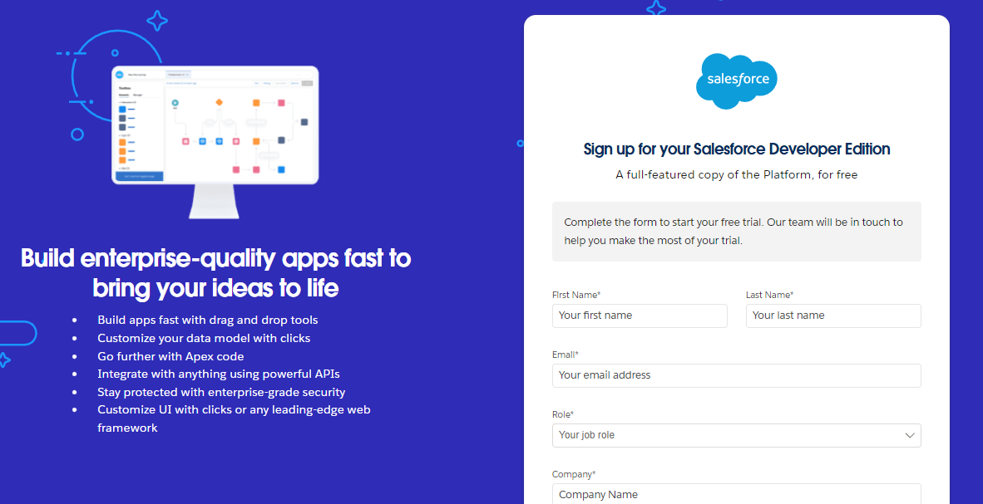](https://developers.salesforce.com/Signup*)

1. First name & Last name
2. Email
3. Role : Developer
4. Company : College Name
5. County : India
6. Postal Code : pin code
7. Username : should be a combination of your name and company

This need not be an actual email id, you can give anything in the format : username@organization.com

Click on sign me up after filling these.

### Account Activation

1. Go to the inbox of the email that you used while signing up. Click on the verify account to activate your account. The email may take 5-10mins.

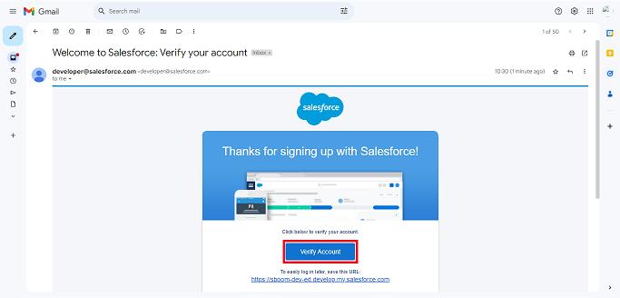

1. Click on Verify Account
2. Give a password and answer a security question and click on change password.

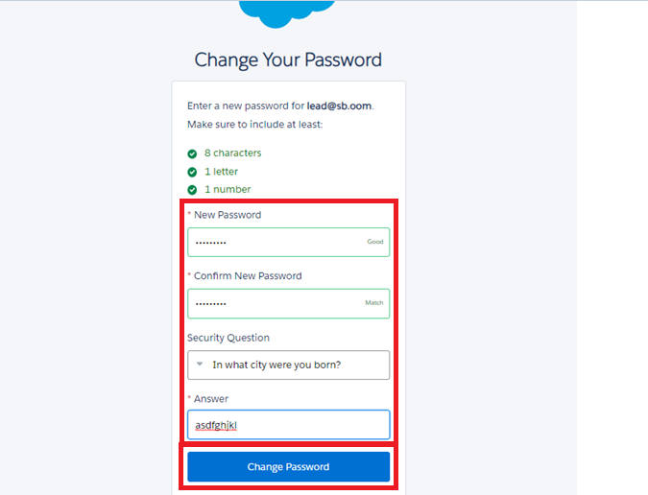

1. Then you will redirect to your salesforce setup page.

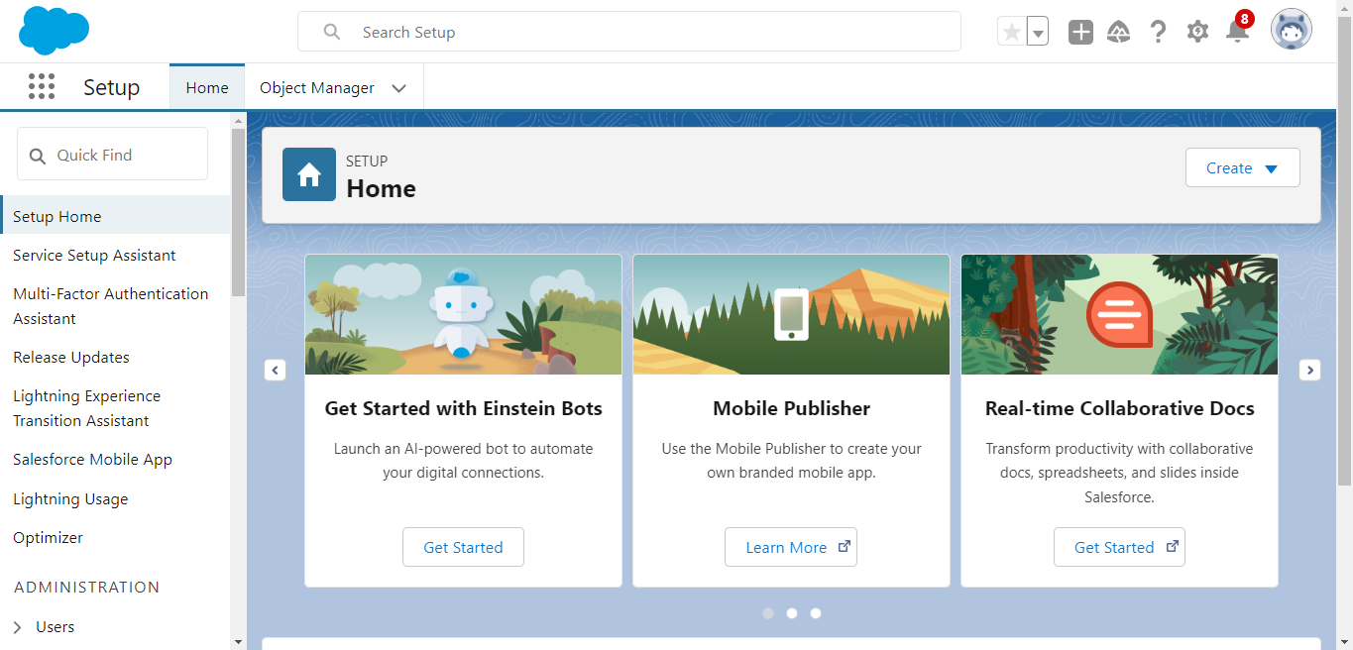

### Create Flight Object

The purpose of creating a Flight custom object is to have a clear picture of the flight details.

To create an object:

1. From the setup page --> Click on Object Manager -->Click on Create --> Click on Custom Object.

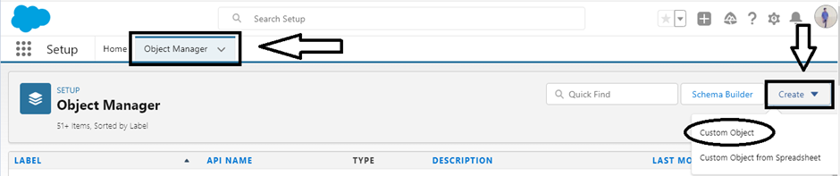

1. Enter the label name--> Flight
2. Plural label name--> Flights
3. Enter Record Name Label and Format

* Record Name : Flight Name
* Data Type : Text

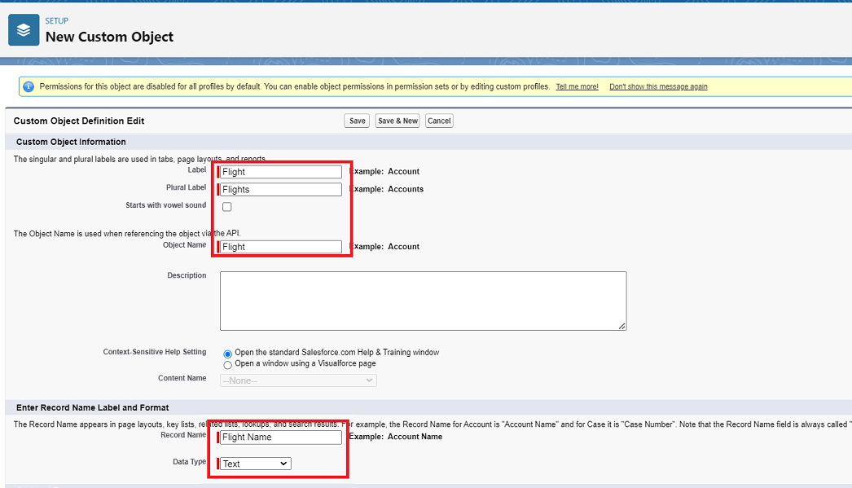

1. Click on Allow reports,
2. Allow search --> Save.

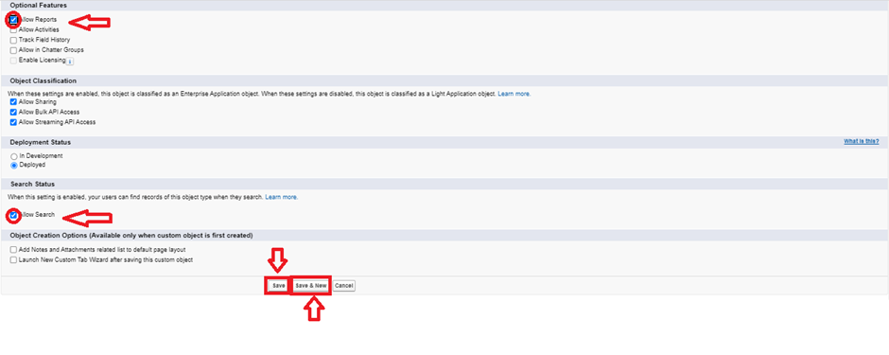

### Create Booking Object

The purpose of creating a Booking object is to have detailed information about booking and reservation of the passengers.

To create an object:

1. From the setup page --> Click on Object Manager --> Click on Create --> Click on Custom Object.
2. Enter the label name--> Booking
3. Plural label name--> Bookings
4. Enter Record Name Label and Format

* Record Name : Booking Id
* Data Type : Auto Number
* Display Format : Bk-{0000}
* Starting Number : 1

1. Click on Allow reports,
2. Allow search --> Save

### Activity 3

Create 2 more objects with record names as Passenger Id and Crew Id.

### Tabs

### Creating A Custom Tab(Flight)

To create a Tab(Flight )

1. Go to setup page --> type Tabs in Quick Find bar --> click on tabs --> New (under custom object tab)   
   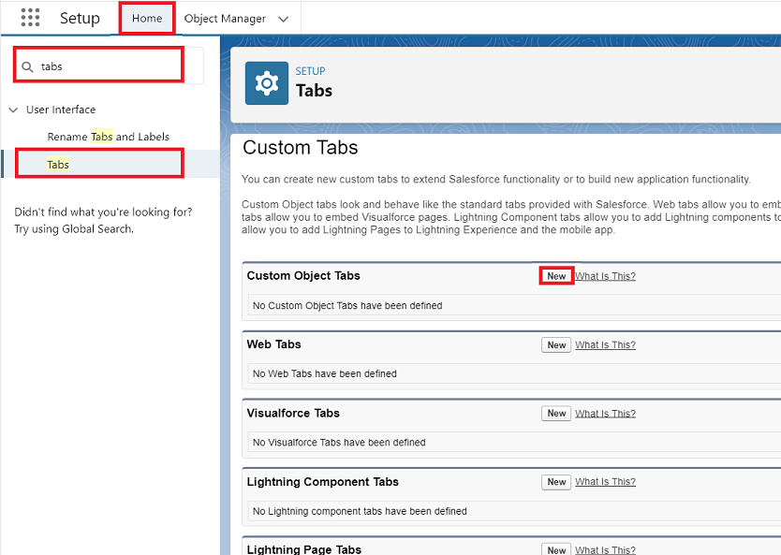
2. Select Object(Flight) --> Select any tab style --> Next (Add to profiles page) keep it as default -> Next (Add to Custom App) keep it as default --> Save.

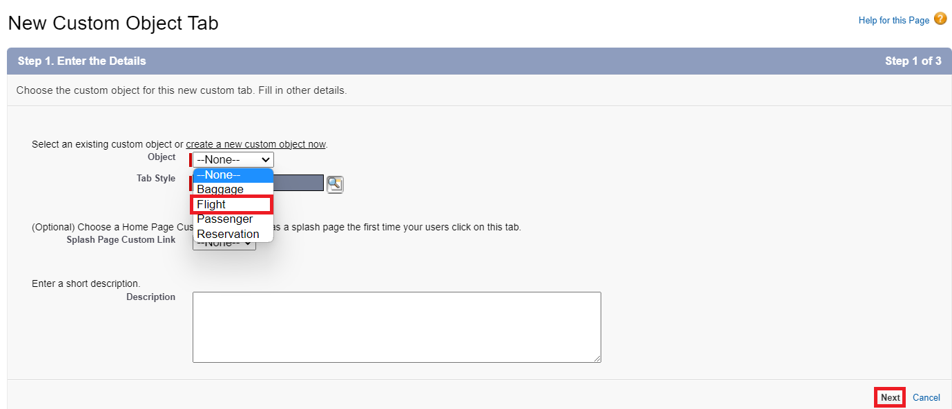

### Creating A Custom Tab(Booking)

To create a Tab (Booking )

1. Go to setup page --> type Tabs in Quick Find bar --> click on tabs --> New (under custom object tab)
2. Select Object(Booking) Select the tab style --> Next (Add to profiles page) keep it as default --> Next (Add to Custom App) keep it as default --> Save.

### Activity 3

Now create tabs for Crew and Passengers objects.

### The Lightning App

### Create A Lightning App

To create a lightning app page:

1. Go to setup page --> search “app manager” in quick find -->select “app manager” -->click on New lightning App.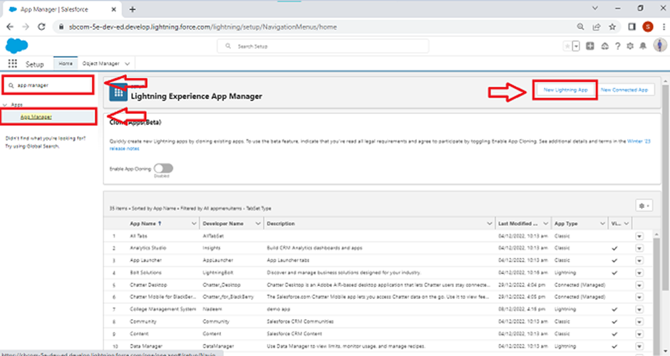
2. Fill the app name in app details and branding as follow  
   App Name : AirLine Management System  
   Developer Name : this will auto populated  
   Description : Give a meaningful description  
   Image : optional (if you want to give any image you can otherwise not mandatory)  
   Primary color hex value : keep this default
3. Then click Next --> (App option page) keep it as default --> Next --> (Utility Items) keep it as default --> Next.  
   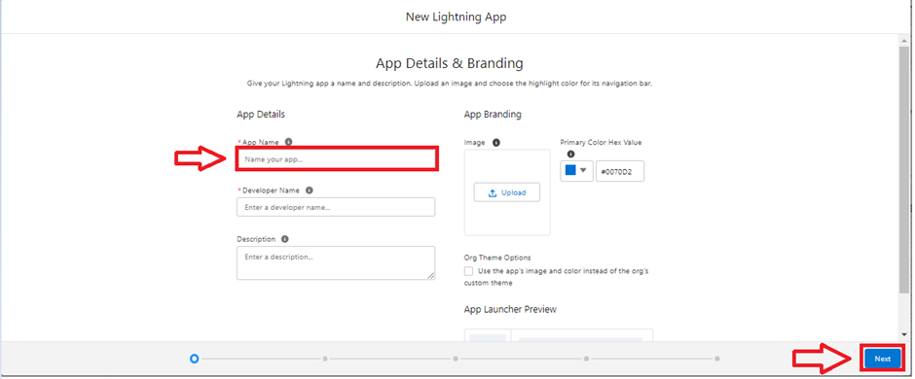
4. To Add Navigation Items:  
   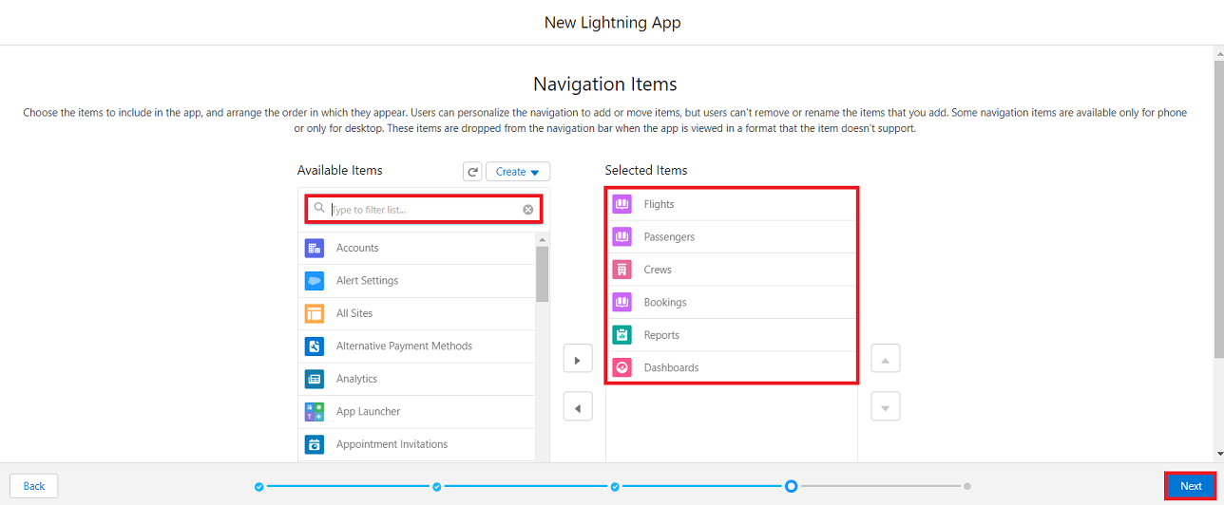  
   Search the items in the search bar(Flight, Passengers, Booking, Crew, Reports, Dashboard) from the search bar and move it using the arrow button --> Next.  
   Note: select the custom object which we have created in the previous activity.
5. To Add User Profiles:

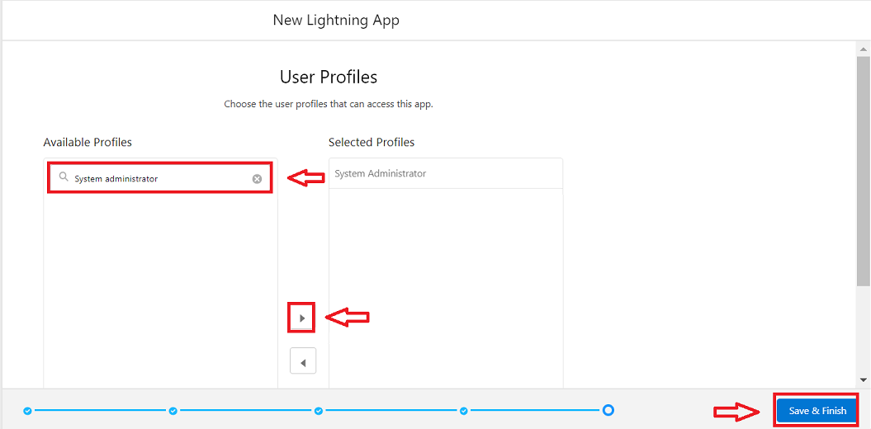

Search profiles (System administrator) in the search bar --> click on the arrow button --> save & finish.

### Fields

### Activity 1: Creating Field In Flight Object

To create fields in an object:

1. Go to setup --> click on Object Manager --> type object name(Flight) in quick find bar--> click on the object.   
   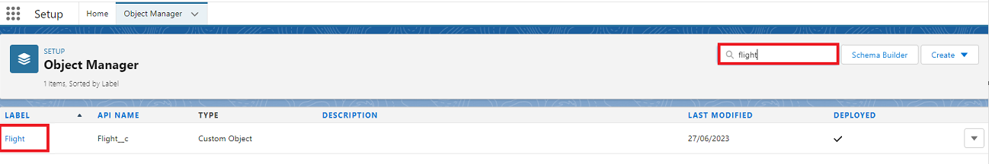
2. Now click on “Fields & Relationships” --> New  
   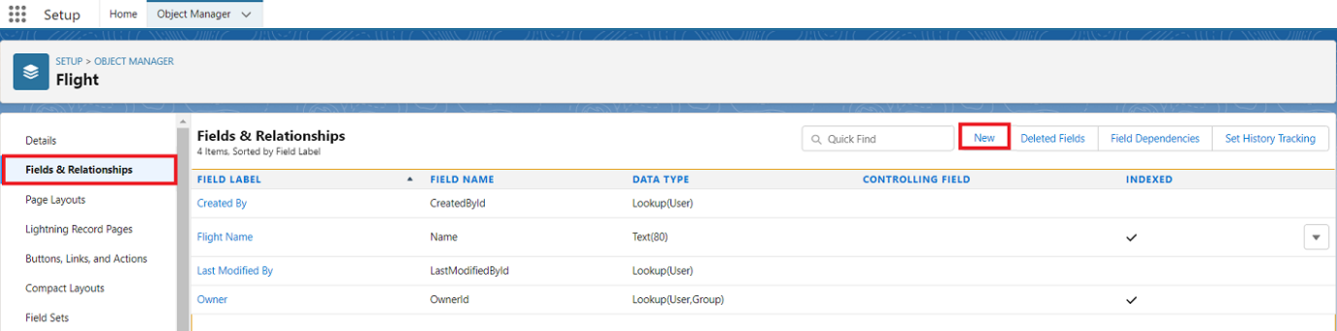
3. Select Data type as “Number”.  
   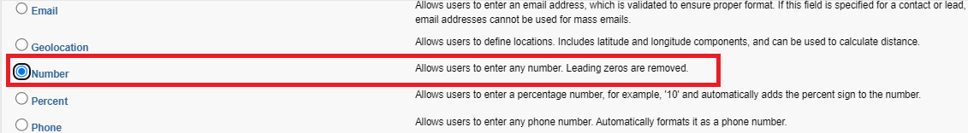
4. Click on Next  
   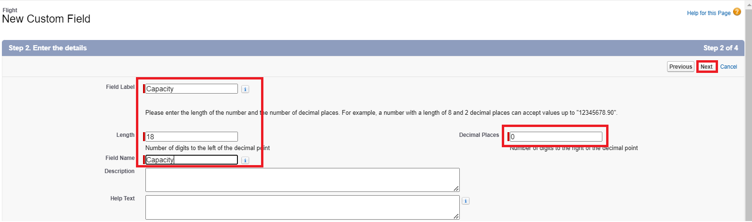
5. Fill the above as following:

* Field Label: Capacity
* Length : 18
* Field Name : gets auto generated
* Click on Next ? Next --> Save and new.

### Activity 2: Creating Departure Date On Booking Object

1. Go to setup ? click on Object Manager ? type object name(Booking) in quick find bar? click on the object.
2. Now click on “Fields & Relationships” ? New.
3. Select Data type as “Date” and click Next.  
   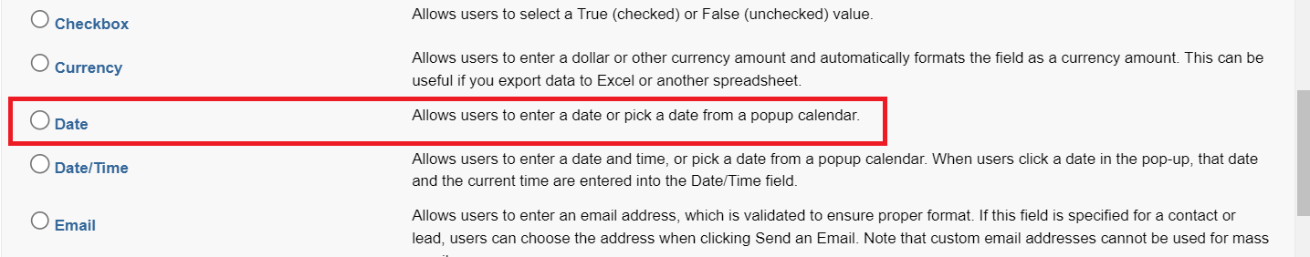
4. Click on Next.
5. Fill the above as following:
   1. Field Label:Departure Date.
   2. Field Name : gets auto generated.
   3. Click on Next --> Next --> Save and new.

### Activity 3: Creating Picklist Field On Flight Object.

1. Go to setup --> click on Object Manager --> type object name(Flight) in quick find bar--> click on the object.
2. Now click on “Fields & Relationships” -->New.
3. Select Data type as “Picklist” and click Next.
4. Enter Field Label as “Departs From”, under values select “Enter values, with each value separated by a new line" and enter values as shown below:

|  |
| --- |
| Delhi Mumbai Bengaluru Chennai Kolkata |

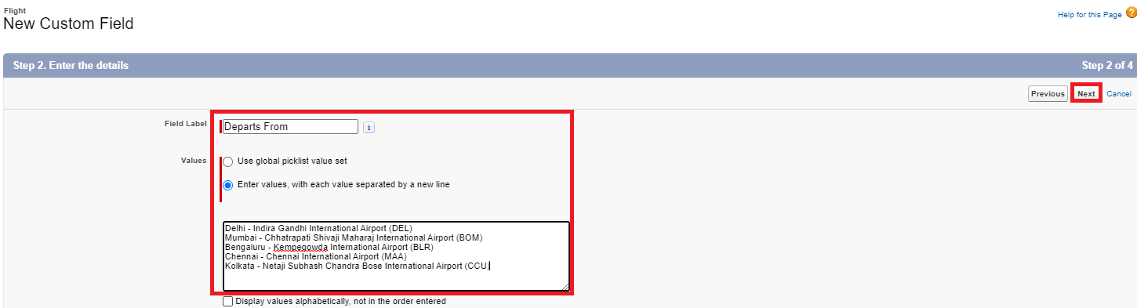

1. Click Next--> Next --> Next --> Save & New.

### Activity 4: Creating Lookup Relationship Between Flight And Booking

Creating Lookup Relationship between Flight & Booking Object

To Create a lookup relationship

1. Go to the setup page --> click on object manager -->type object name(Booking) in the quick find bar--> click on the object.
2. Click on fields & relationship --> click on New.
3. Select “lookup relationship” as data type and click Next.
4. For field label related to: select “Flight” object and click Next.
5. Give Field Label as “Flight” and click Next.
6. Next --> Next --> Save.

### Activity 5: Creating Remaining Fields

Now create the remaining fields using the data types mentioned in the table.

|  |  |  |  |
| --- | --- | --- | --- |
| Sl No | Object | Field | Datatype |
| 1 | Passenger | 1. Name 2. Phone 3. Passport Number 4. Passport Issue Date 5. Passport Expiry Date 6. Date of Birth 7. Nationality | Text  Phone  Number  Date  Date  Date  Picklist : Values as below   |  | | --- | | India  China  USA  Canada Mexico Australia  South Korea  North Korea  Germany | |
| 2 | Booking | 1. Passenger Name 2. Departs From 3. Departs To 4. Travellers 5. Class | Lookup relationship with Passenger  Picklist : Values are same as Activity 3  Picklist : Values are same as Activity 3  Picklist : Values as below   |  | | --- | | Adult  Child  Infant |   Picklist : Values as below   |  | | --- | | Economy  Business  First Class | |
| 3 | Flight | 1. Departs to 2. PNR Number 3. Departure Date 4. Departure Time 5. Arrival Time | Picklist : Values are same as Activity 3  Number  Date  Time  Time |
| 4 | Crew | 1. Flight 2. Crew Member 3. Phone 4. Email 5. Qualification 6. Role | Lookup relationship with Flight  Text(20)  Phone  Email  Text  Picklist: Values as below   |  | | --- | | Pilot  Co-Pilot  Flight Attendants  Air Hosts  Air Hostesses  Air Stewards  Air Stewardesses  On-Board Chefs | |

### Activity 6: Creating Field Dependencies

To create a field dependency:

1. Go to object manager -->select the object (flight) --> click fields & relationships --> click “Field Dependencies”.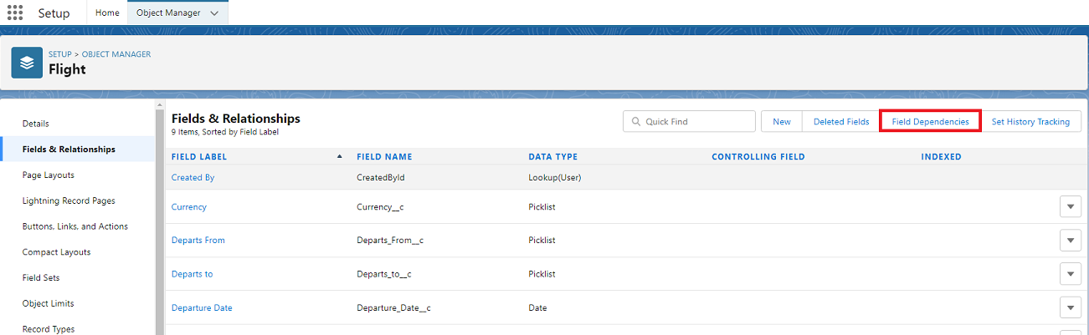
2. Click “New” under Field Dependencies.  
   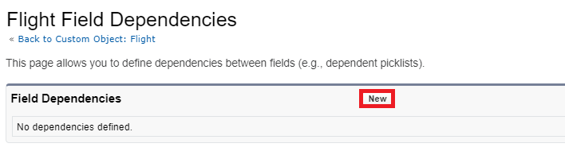
3. Select “Departs From” for Controlling Field.
4. Select “Departs to” for Dependent Field and click Continue.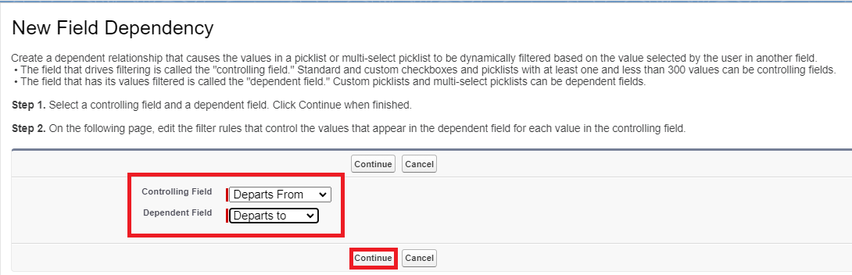
5. While pressing CTRL button select the values as shown below and click on include values.  
   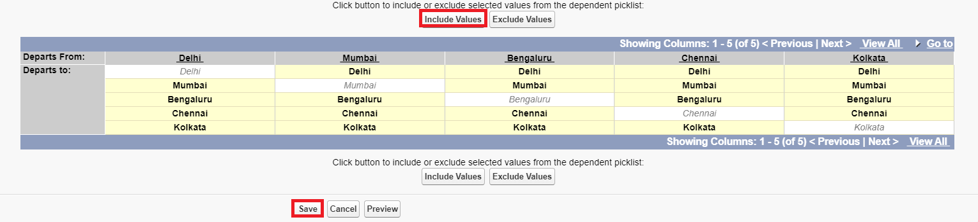
6. Click on Save.

### Activity 7

## **Create similar Field dependencies for booking object as we have done in activity 6.**

### Activity 8: Schema Builder

Schema Builder is a powerful tool within Salesforce that allows you to visualise, explore, and design the relationships between objects in your Salesforce organisation. It provides a graphical representation of the data model, making it easier to understand the structure and connections between different objects.

Creating Schema Builder

1. Go to setup --> click on Object Manager --> Schema Builder.

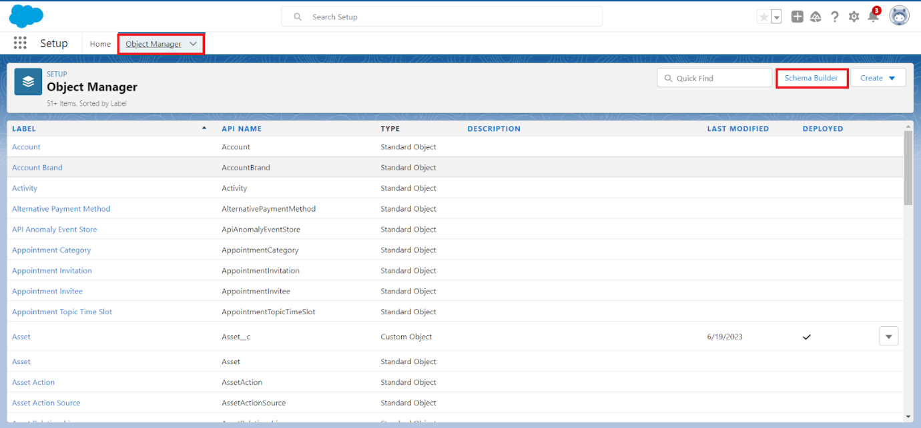

1. Click on Clear All
2. Select objects--> Enter Objects which we have created in the above Milestone 2 (Passenger, Booking, Flight & Crew) in a quick box and select them.

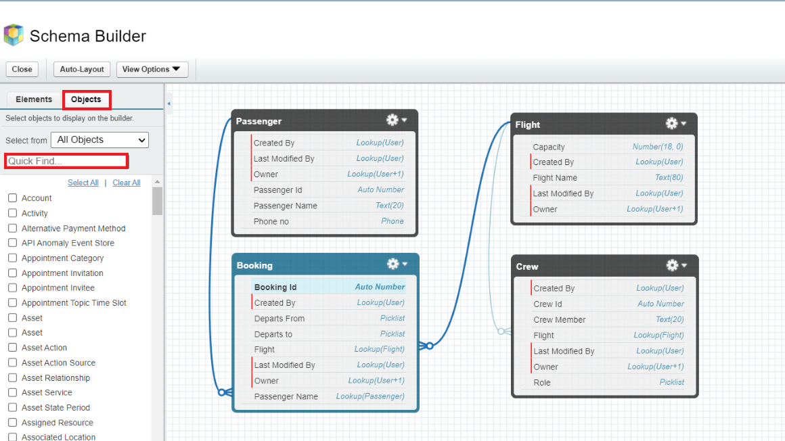

### Milestone 6 - User Adoption

### Activity 1: Create A Record (Passenger)

1. Click on App Launcher on the left side of the screen.
2. Search AirLine Management System & click on it.  
   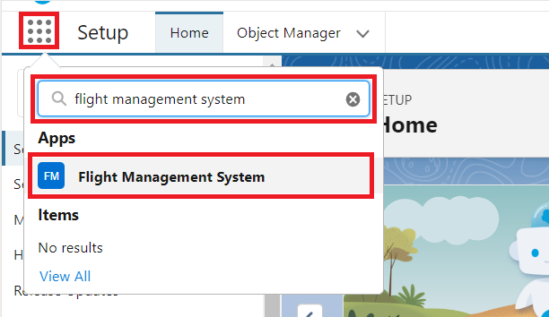
3. Click on the Passenger tab.
4. Click  New.  
   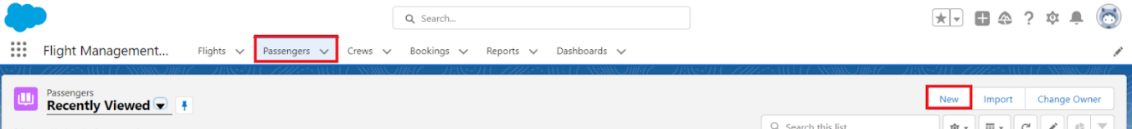
5. Fill the Details and click on Save.

### Activity 2: View A Record(Passenger)

1. Click on App Launcher on the left side of the screen.
2. Search AirLine Management System & click on it.
3. Click on the Passenger Tab.
4. Click on any record name. you can see the details of the Passenger.

### Activity 3: Delete A Record(Passenger)

1. Click on App Launcher on the left side of the screen.
2. Search AirLine Management System & click on it.
3. Click on the Passenger Tab.
4. Click on Arrow at right hand side on that Particular record.
5. Click delete.

### Activity 4:

Create at least 10 records for each of the objects: Passenger, Booking, Flight, Crew.

### Milestone 7 : Profiles

### Activity 1: General Admin Profile

To create a new profile:

1. Go to setup --> type profiles in quick find box --> click on profiles --> clone the desired profile (Standard Platform User)-->enter profile name (General Admin)--> Save.

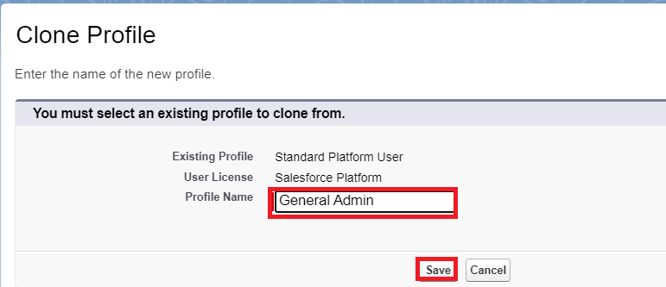

1. While still on the profile page, then click Edit.
2. Scroll down to Custom Object Permissions and Give access permissions for read, create and edit on Passenger, and booking objects.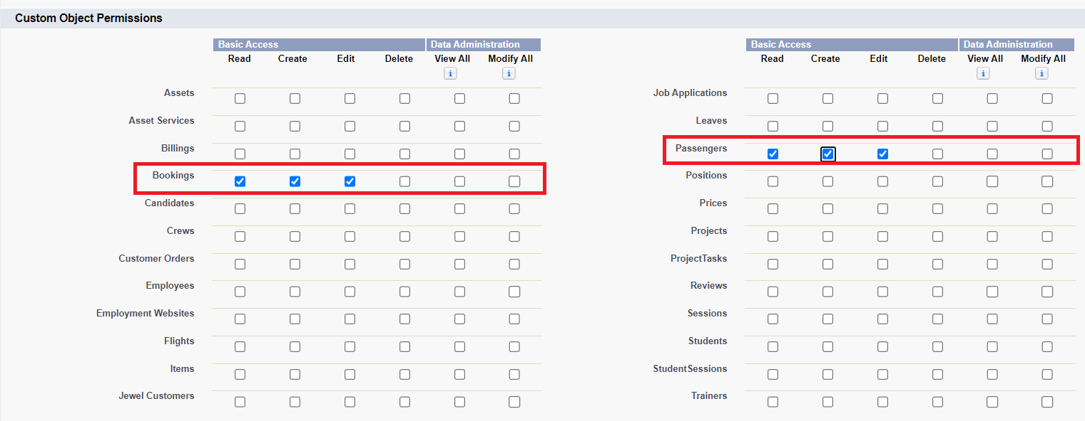
3. Scroll down and Click on Save.

### Activity 2: Management Admin Profile

1. Go to setup --> type profiles in quick find box --> click on profiles --> clone the desired profile (Standard Platform User) --> enter profile name (Management Admin) -->Save.
2. While still on the profile page, then click Edit.
3. Scroll down to Custom Object Permissions and Give access permissions for read, edit and create Flight and Crew.
4. Scroll down and Click on Save.

### Activity 3: Create Senior Admin & Crew Member Profiles

Create Crew Member Profile for Crew Members and give them access permission to read only as we have done in the previous activity.

Create Senior Admin Profiles for Senior Admin in the Organization and give him access permission to read, create, edit and delete for all 4 objects.

Note: for Senior Admin clone System Administrator profile.

### Milestone 8 : Role

### Activity 1: Creating Admin Manager Role

1. Go to quick find --> Search for Roles --> click on set up roles.

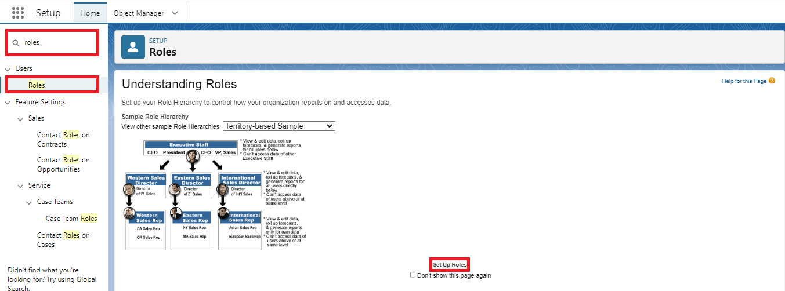

1. Click on Expand All and click on add role under whom this role works.

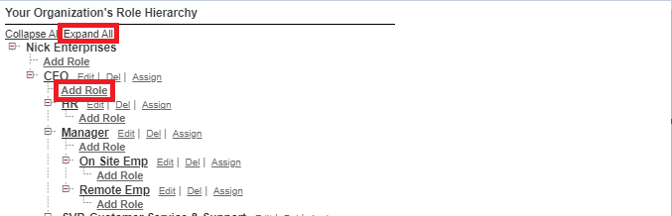

1. Give Label as “Senior Admin” and Role name gets auto populated. Check to whom this role (Senior Admin) reports. Then click on Save.

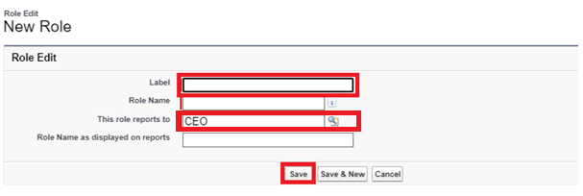

1. Refer the below diagram to understand which role reports to which role.

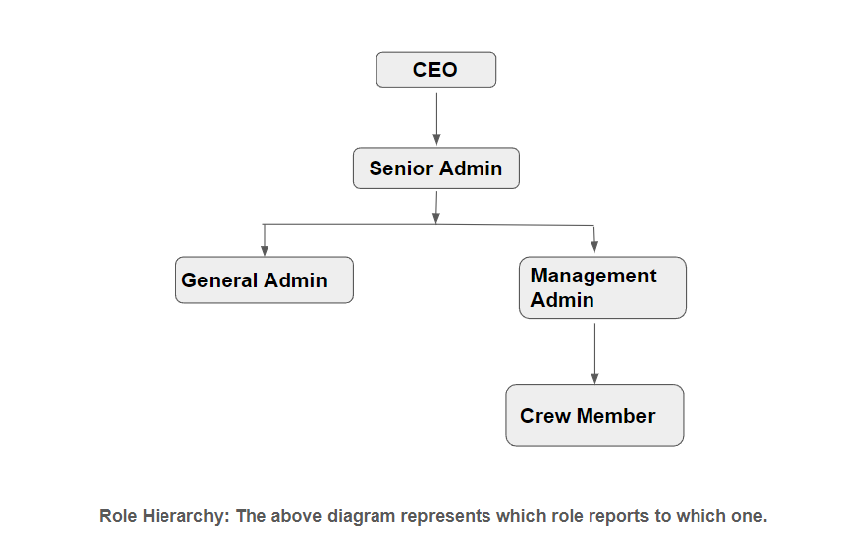

### Activity 2:

Create three more roles for General Admin, Management Admin and Crew Member.

Note: Crew Members report to Management Admin, Management Admin & General Admin Reports to Senior Admin and only Senior Admin reports to CEO.

### Milestone 9 : Users

### Activity 1: Create User

1. Go to setup --> type users in quick find box --> select users --> click New user.
2. Fill in the fields
3. First Name : Niklaus
4. Last Name : Mikaelson
5. Alias : Give a Alias Name
6. Email id : Give your Personal Email id
7. Username : Username should be in this form: text@text.text
8. Nick Name : Give a Nickname
9. Role : Senior Admin
10. User licence : Salesforce
11. Profiles : Senior Admin  
    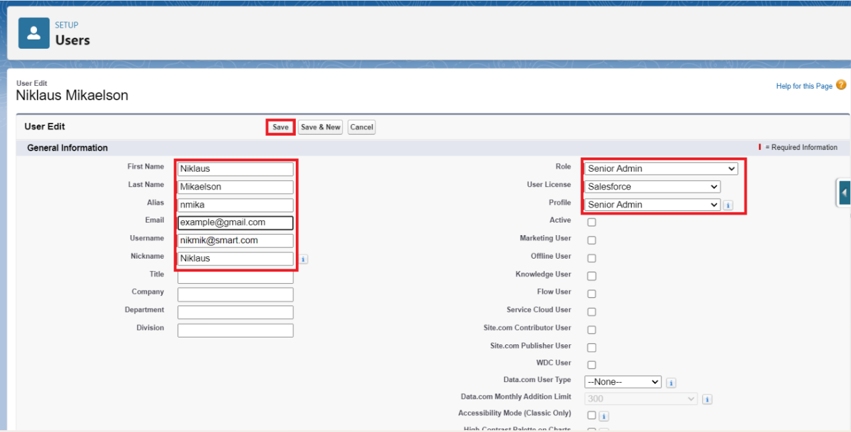
12. Save.

### Activity 2

1. Go to setup --> type users in quick find box --> select users --> click New user.
2. Fill in the fields

* First Name : Kol
* Last Name : Mikaelson
* Alias : Give a Alias Name
* Email id : Give your Personal Email id
* Username : Username should be in this form: text@text.text
* Nick Name : Give a Nickname
* Role : General Admin
* User license : Standard Platform
* Profiles : General Admin

1. Save.

### Activity 3

Create two more users for Management Admin and Crew Members as mentioned in activity 2.

### Milestone 10 : Reports

### Activity 1

Create Report

1. Go to the app --> click on the reports tab
2. Click New Report.

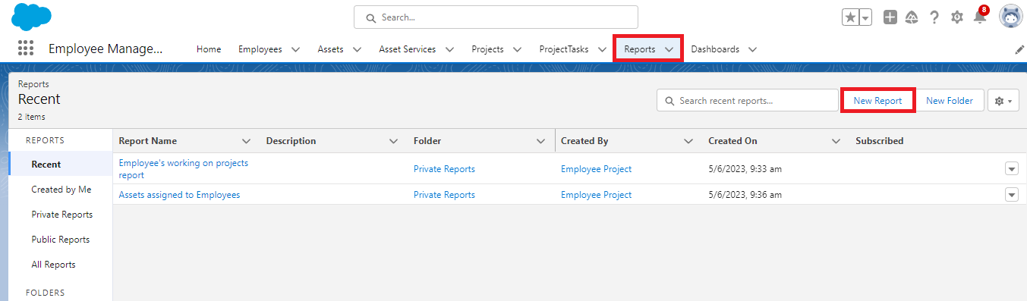

1. Select report type from category or from report type panel or from search panel --> click on start report.

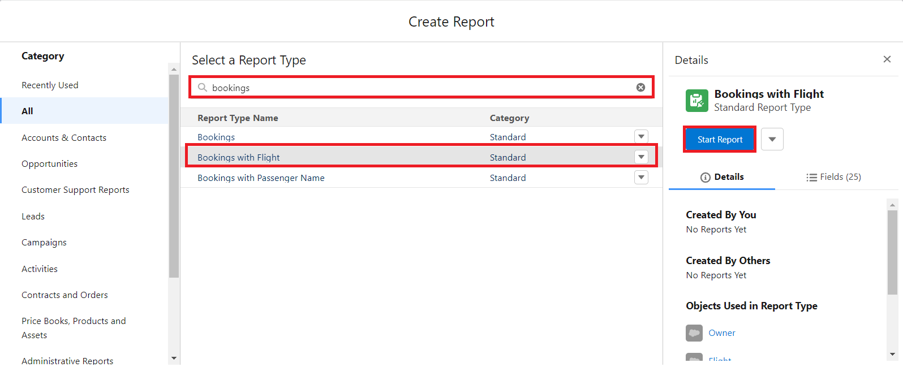

1. Customize your report

* Check the toggle on the update preview automatically button.
* Add fields from the left pane as shown below.
* Add the “Traveller” field in Group Rows.
* Turn the toggle off for the subtotal button.

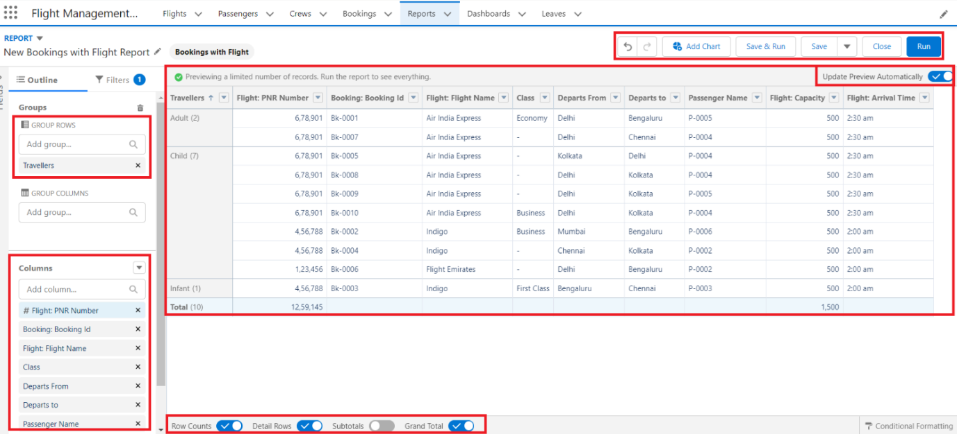

1. Click on save.
2. Save the report as “Bookings with Flight Details”.  
   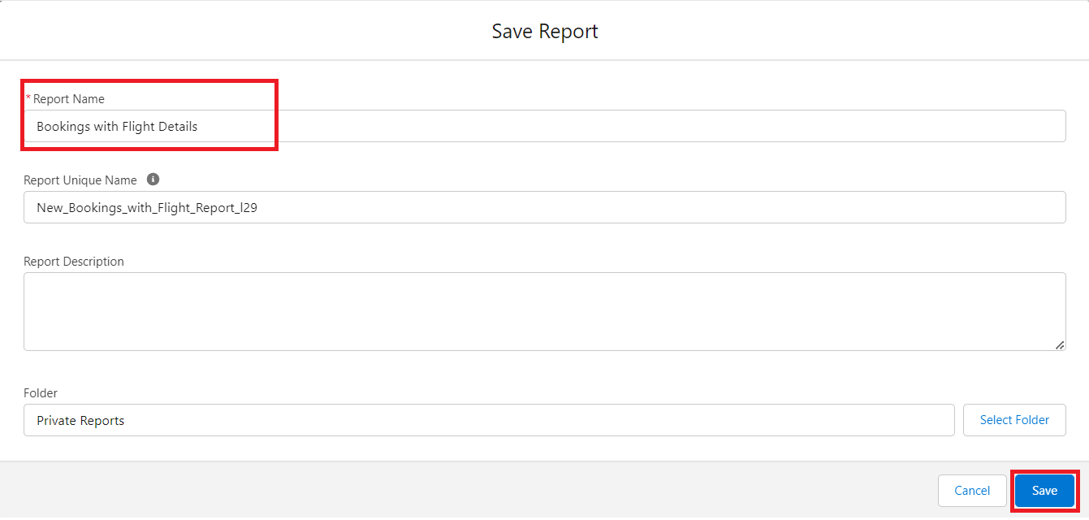
3. Click on Save.

Note: Reports may get varied from the above pictures as the data might be different.

### Activity 2

1. Create a report with a report type: “Booking with Passenger Name”.
2. Create a report with report type: “Crew with Flight”.

### Milestone 11 : Dashboards

### Activity 1

Create Dashboard

1. Go to the app --> click on the Dashboards tabs.

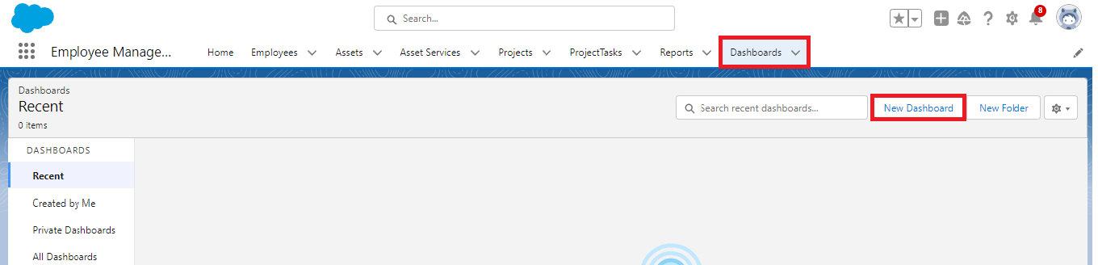

1. Give a Name and click on Create.

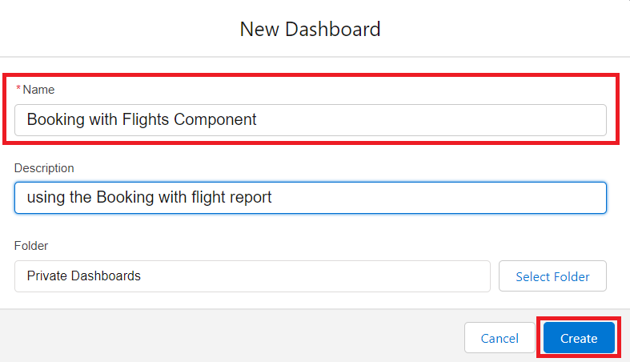

1. Select add component.



1. Select a Report and click on select.

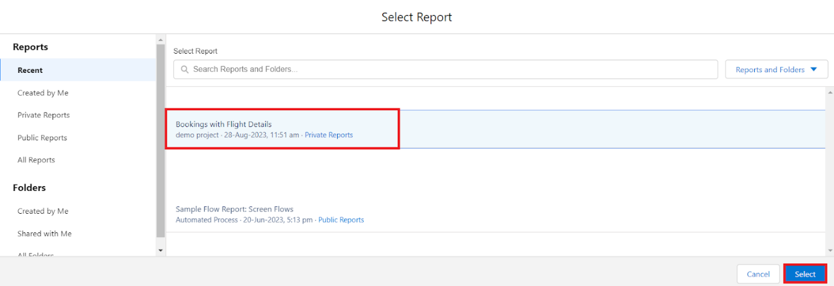

1. Select the Donut option under display as and click on Add.  
   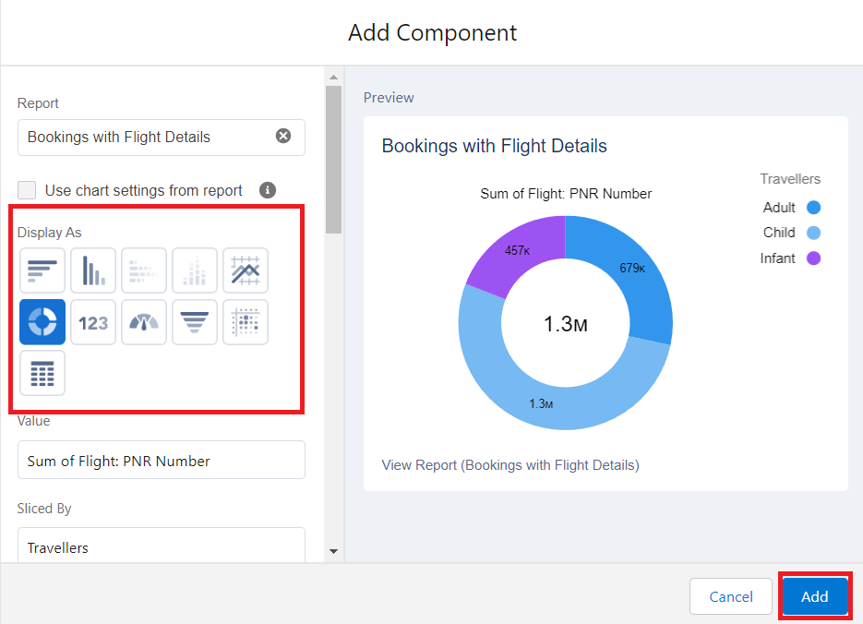
2. Your dashboard display as below:  
   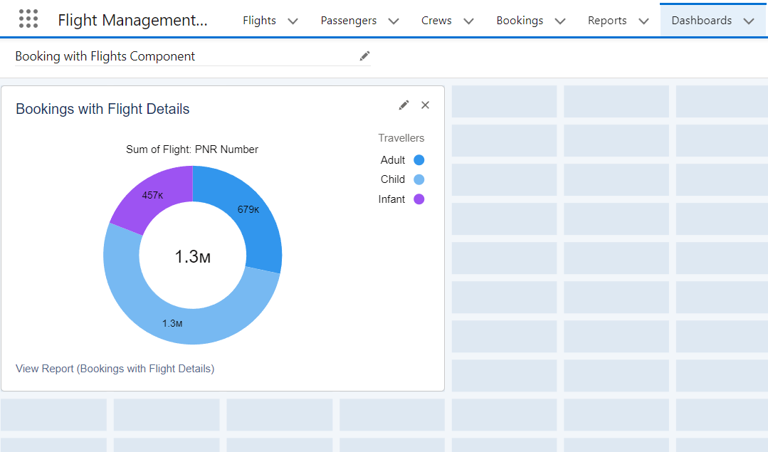

### Activity 2

Create two more  Dashboards using the reports which we have created in the milestone 10 activity 2.

### Milestone 12: Apex

### Activity 1 : Create An Apex Class

1. Go to Setup --> Click on the gear icon --> Select Developer Console.  
   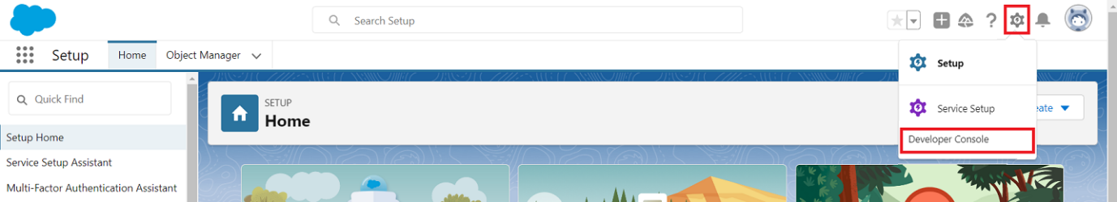
2. Then we can see the Developer console. Click on the developer console and you will navigate to a new console window.
3. To create a new Apex Class follow the below steps:  
   Click on the file --> New --> Apex Class.  
   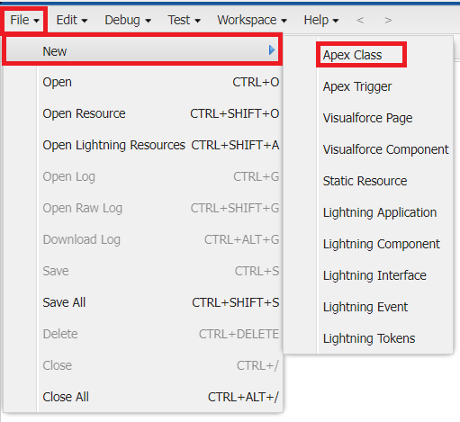
4. Give the Apex Class name as “PhnValid_PassengerObj”.  
   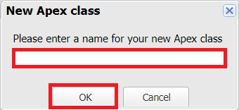
5. Click ok.
6. Now write the code logic here  
   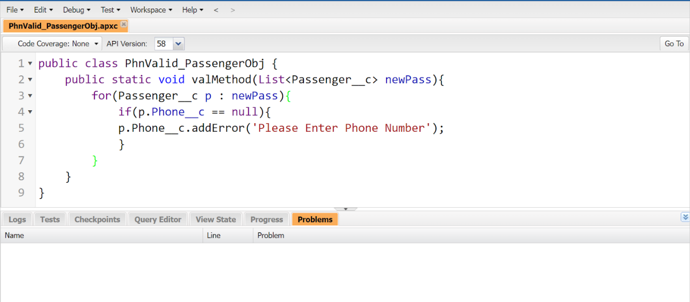  
     
   Source Snippet:

public class PhnValid_PassengerObj {

public static void valMethod(List<Passenger__c> newPass){

for(Passenger__c p:newPass){

if(p.Phone__c==null){

p.Phone__c.addError('please Enter phone Number');

}

}

}

}

1. Save the code.(click on file --> Save)

### Activity 2 : Create An Apex Trigger

1. To create a new Apex Class follow the below steps:  
   Click on the file --> New --> Apex Class.  
   
2. Give the Apex Trigger name as “PhnValidTrigger”, and select “Passenger__c” from the dropdown for sObject.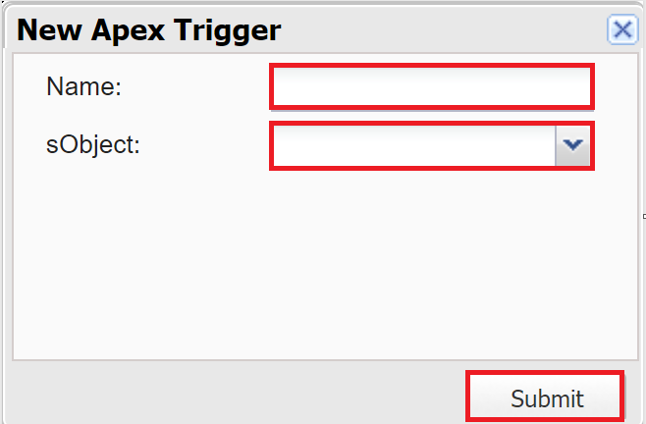
3. Click Submit.
4. Now write the code logic here  
   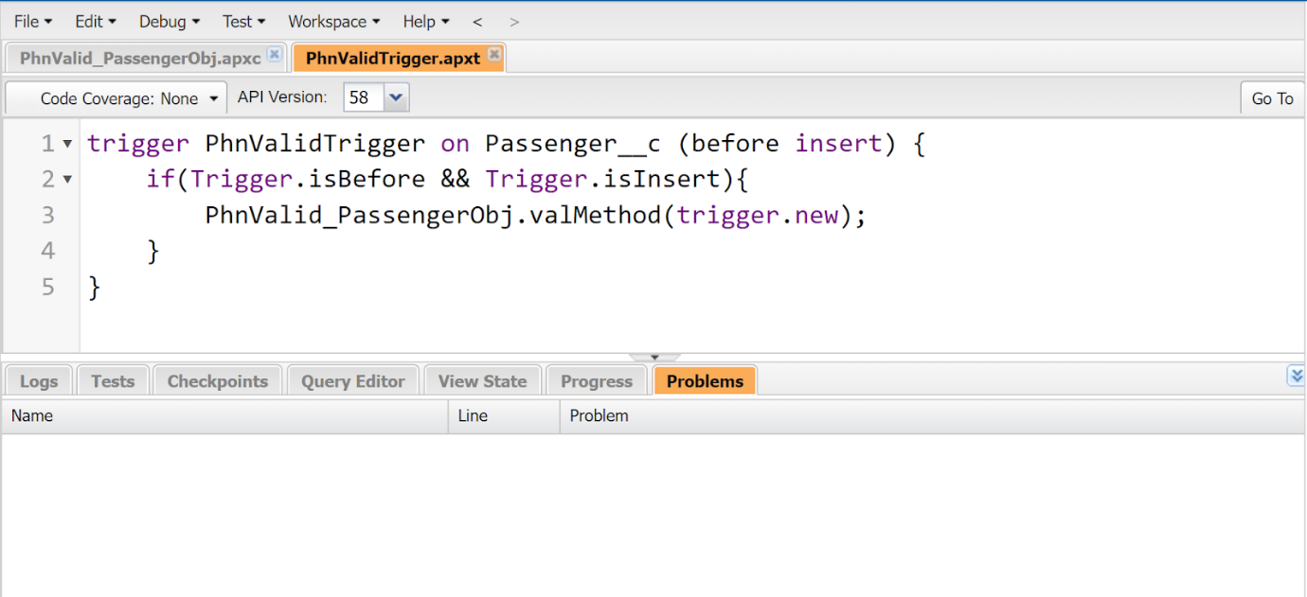

Source Code:

trigger PhnValidTrigger on passenger__c (before insert) {

if(trigger.isBefore && trigger.isInsert){

PhnValid_PassengerObj.valMethod(trigger.new);

}

}

1. Save the code.(click on file --> Save)

### Activity 3 : Create An Apex Test Class

1. To create a new Apex Class follow the below steps:  
   Click on the file --> New --> Apex Class.  
   
2. Give the Apex Class name as “PhnValid_TestClass”.  
   
3. Click ok.
4. Now write the code logic here  
   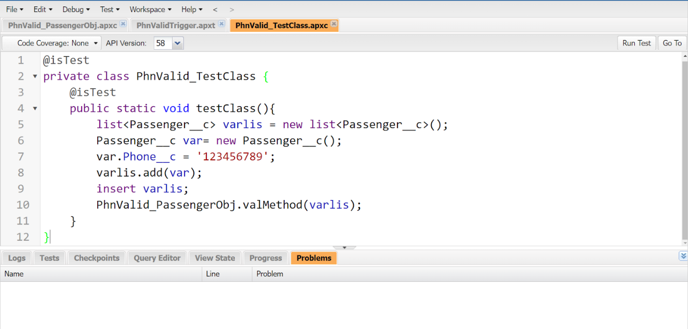

Source Code:

@isTest  
public class PhnValid_TestClass {

    @isTest

    public static void testClass(){  
        list <Passenger__c> varlis = new list<Passenger__c>();  
        Passenger__c var = new Passenger__c();  
        var.Phone__c = null;  
        varlis.add(var);  
        insert varlis;  
        PhnValid_PassengerObj.valMethod(varlis);  
    }

}

1. Save the code.(click on file --> Save).
2. Click on “Run Test” and then click on Test under the terminal section and do check that your overall code coverage should be more than 75%.  
   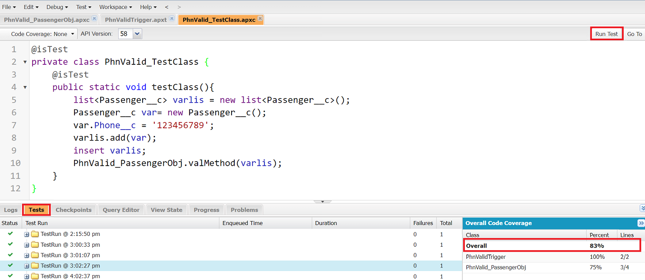

### Milestone 13 : Flows

### Activity 1 : Creating A Screen Element On Booking Object

Let’s start by creating a screen flow and adding a screen to it.

1. From Setup search for the “Flows” in quick find and select “New Flow”.  
   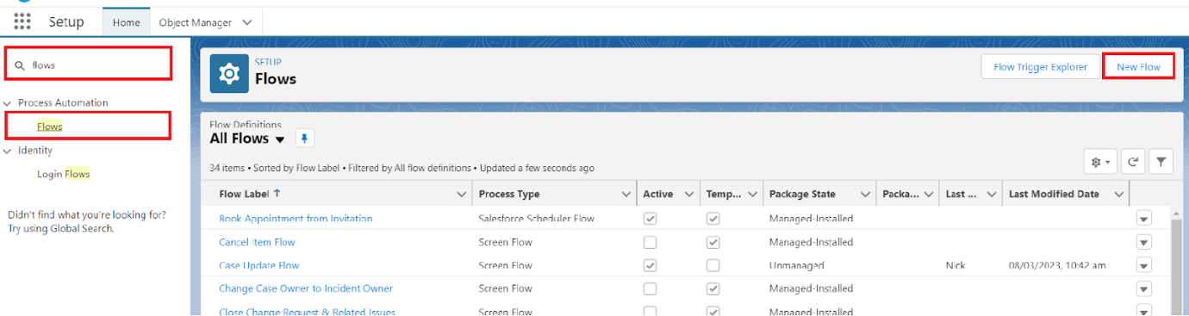
2. Select “Screen Flow” and then click on “Create”.  
   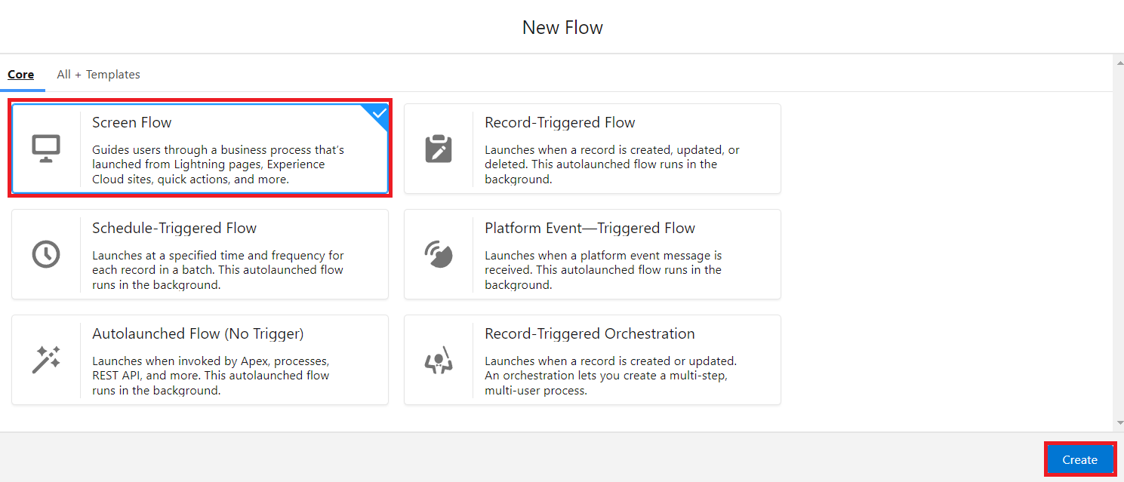
3. Place the cursor in between the Start and End element, a “+” icon appears, click on that and select “Screen”.  
   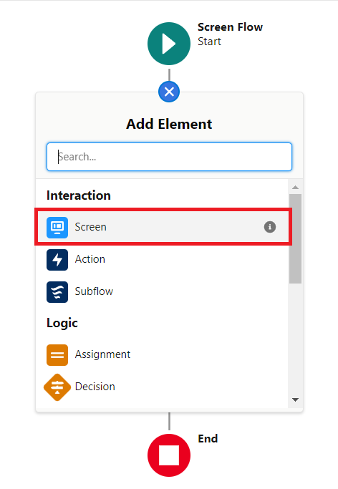
4. Give the label as “Booking Screen”, and select “Fields”.  
   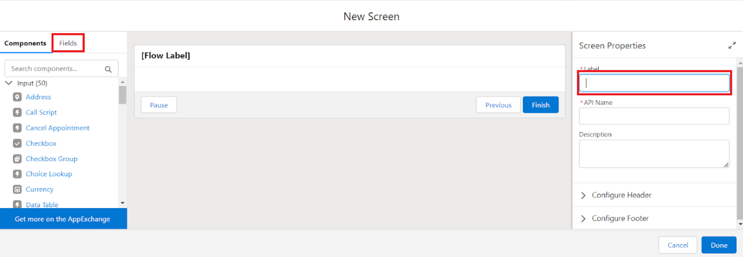
5. Click on the lookup icon in the input field and select “New Resource”.  
   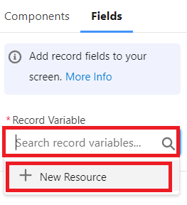
6. Filling the fields as given below:
   1. API name : bookingObject
   2. Datatype : Record
   3. Object : Booking
   4. Available for input : Checked
   5. Available for output: Checked

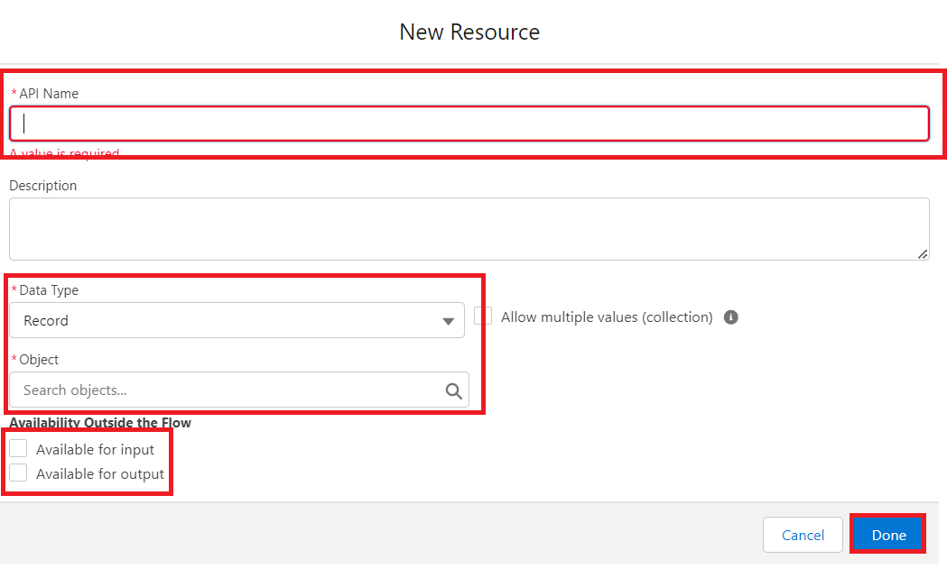

1. Click on done
2. Once you are done with the creation of a resource with the name “bookingObject” go back to step 5 and click on the lookup icon and select “bookingObject” from the list.
3. After selecting “bookingObject” you’ll have all the fields which are in the object, drag and drop each field on the screen.
4. Your screen will look like as shown below:  
   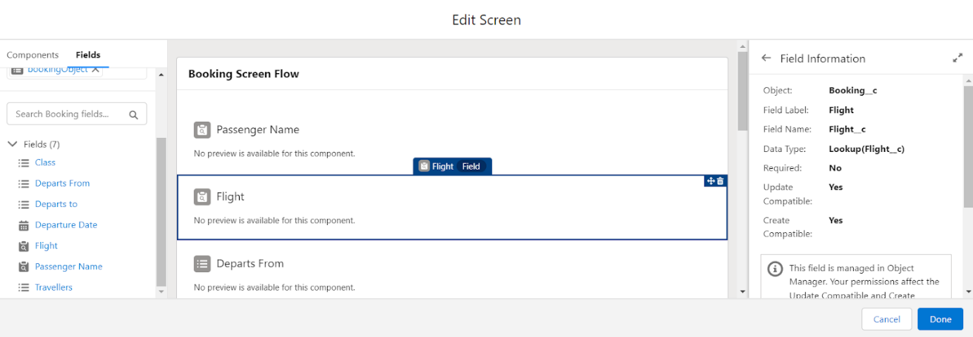
5. Click on done and Save.
6. The flow will look like as shown below.  
   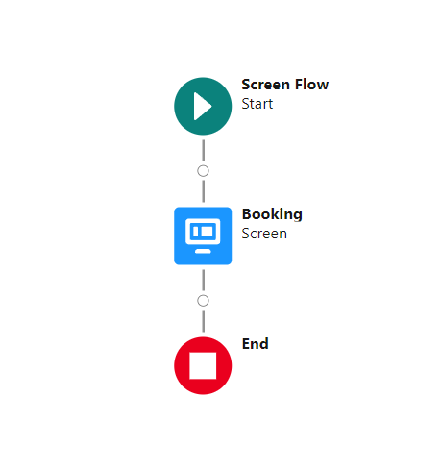

Let’s create a “Create Element” and add it to screen flow.

### Activity 2 : Creating A Create Element On Booking Object

1. In the Create New path, hover over circle and click '+' icon in between booking screen and end.
2. Click Create Records.
3. In the New Create Records window, enter these values.

|  |  |
| --- | --- |
| Field | Value |
| Label | Create Booking Record |
| API name | Gets autopopulated |
| How many records to create | one |
| How to set the record fields | Use separate resources and literal values |
| Object | Booking |

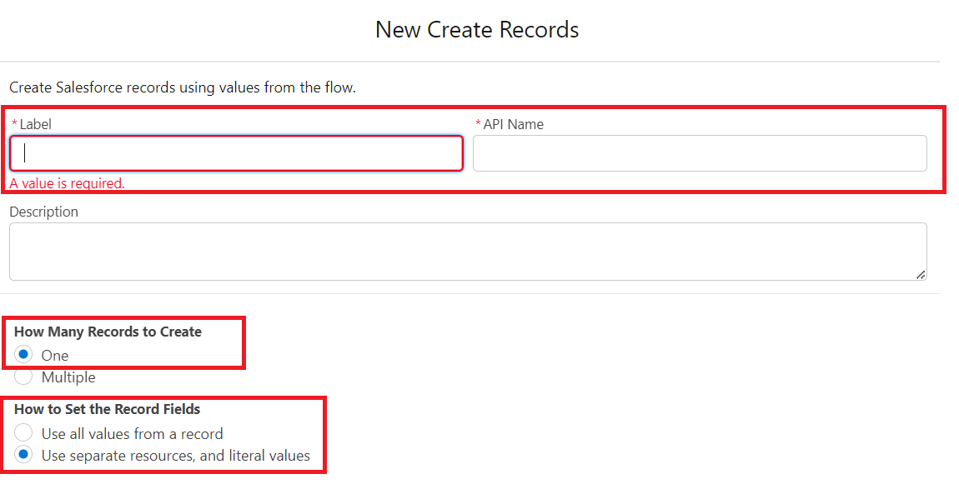

1. Map the fields as shown below:  
   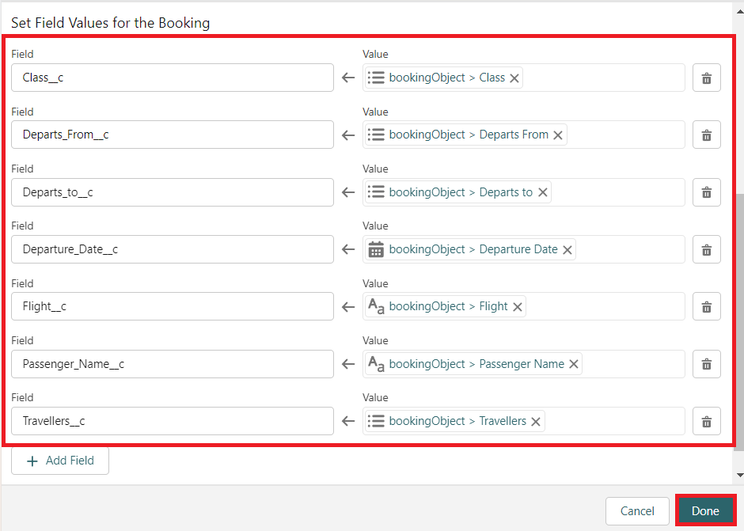
2. Click Done.

### Activity 3 : Creating A Success Screen Element

1. In the Create New path, hover over circle and click '+' icon in between Create Booking Record and end.
2. Click the Screen element.
3. Give a label name as “SuccessScreen”.
4. From components search “Display text” and drag that component in the canvas and give an API Name as “SuccessMessage”.
5. Inside the text area copy this message.  
     
   We are happy to inform you that your booking for [tour name] is confirmed! Get ready to create some unforgettable memories. We’ve made things easy for you and included all of your booking details in this very email. All you need to do is show us this email on the day you arrive, and you’ll be good to go!

Date: {!bookingObject.Departure_Date__c}

Departs from: {!bookingObject.Departs_From__c}

Departs to: {!bookingObject.Departs_to__c}

Class: {!bookingObject.Class__c}

Travellers: {!bookingObject.Travellers__c}

              Passengers Name: {!bookingObject.Passenger_Name__r.Passenger_Name__c}

We can’t wait to see you!

1. Click Done
2. Save the flow and Activate it.

Thank you…!!